PRODUCT PAGE

* Quality Pictures of Wetula Scale, different perspectives, colors, and variations.

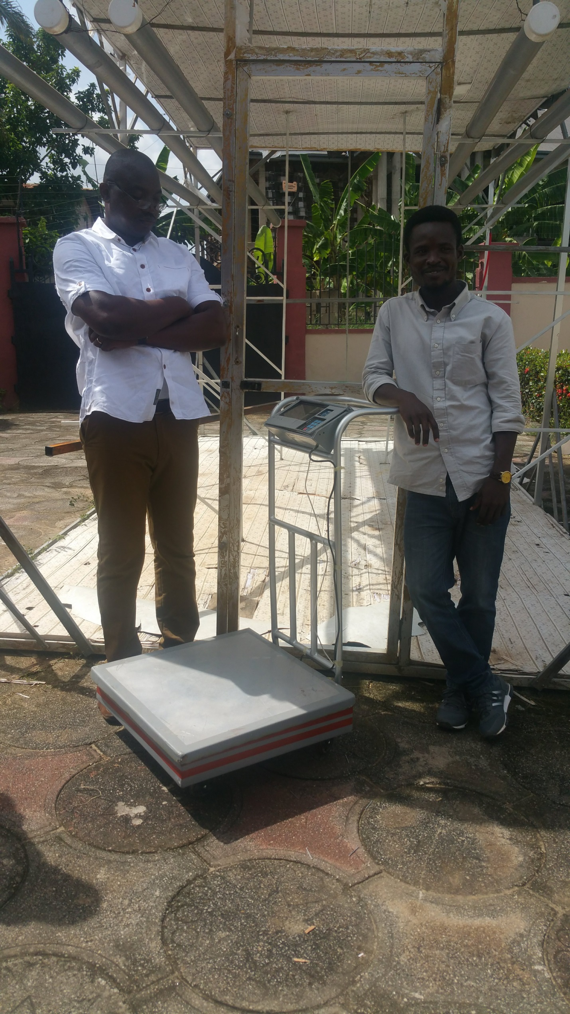

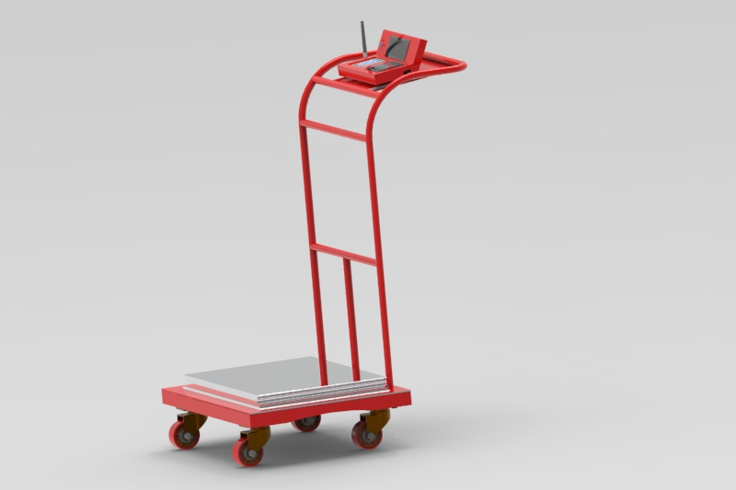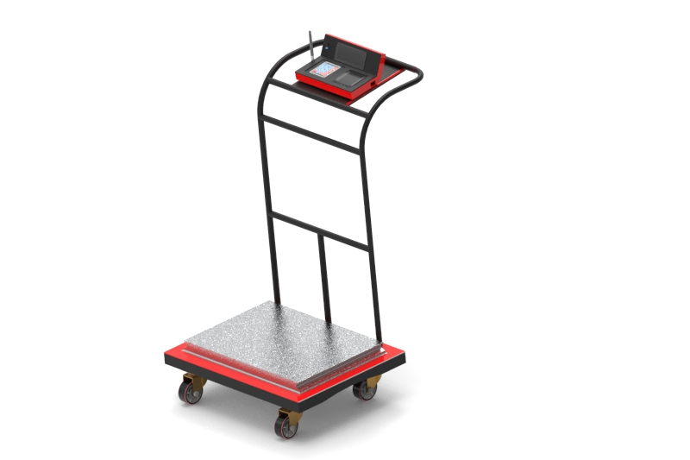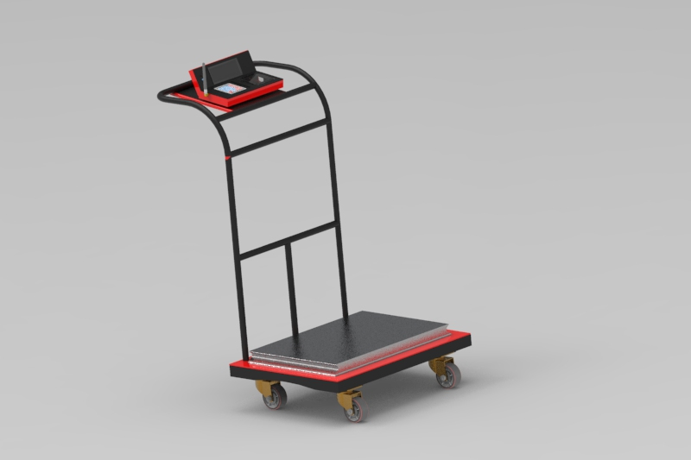

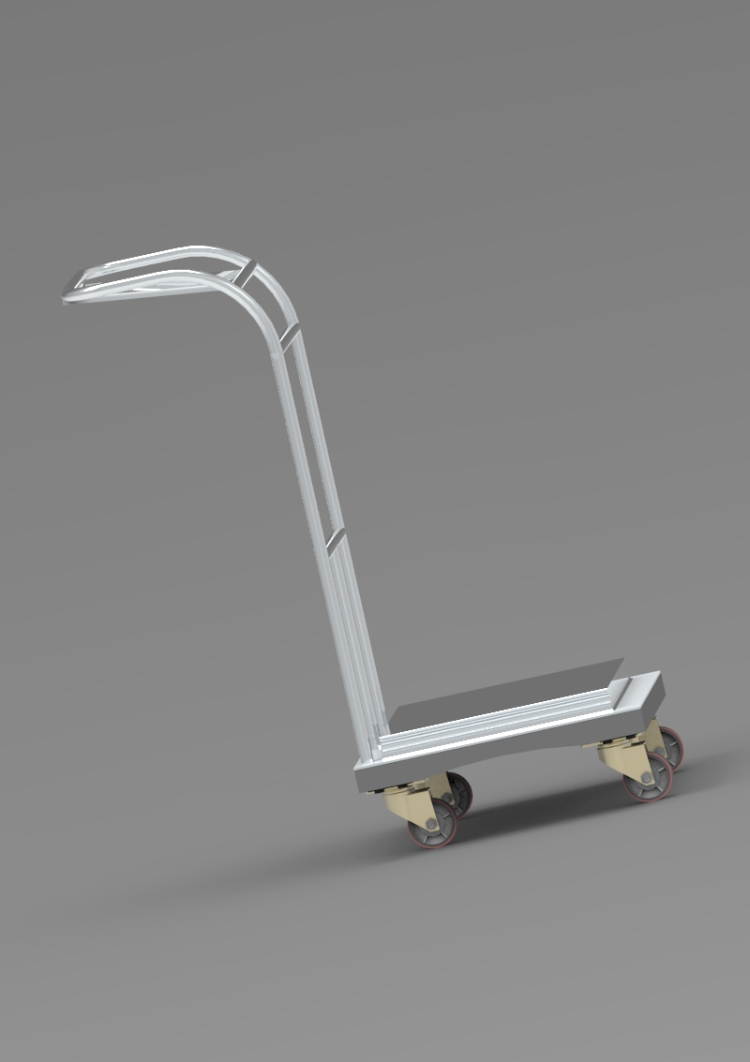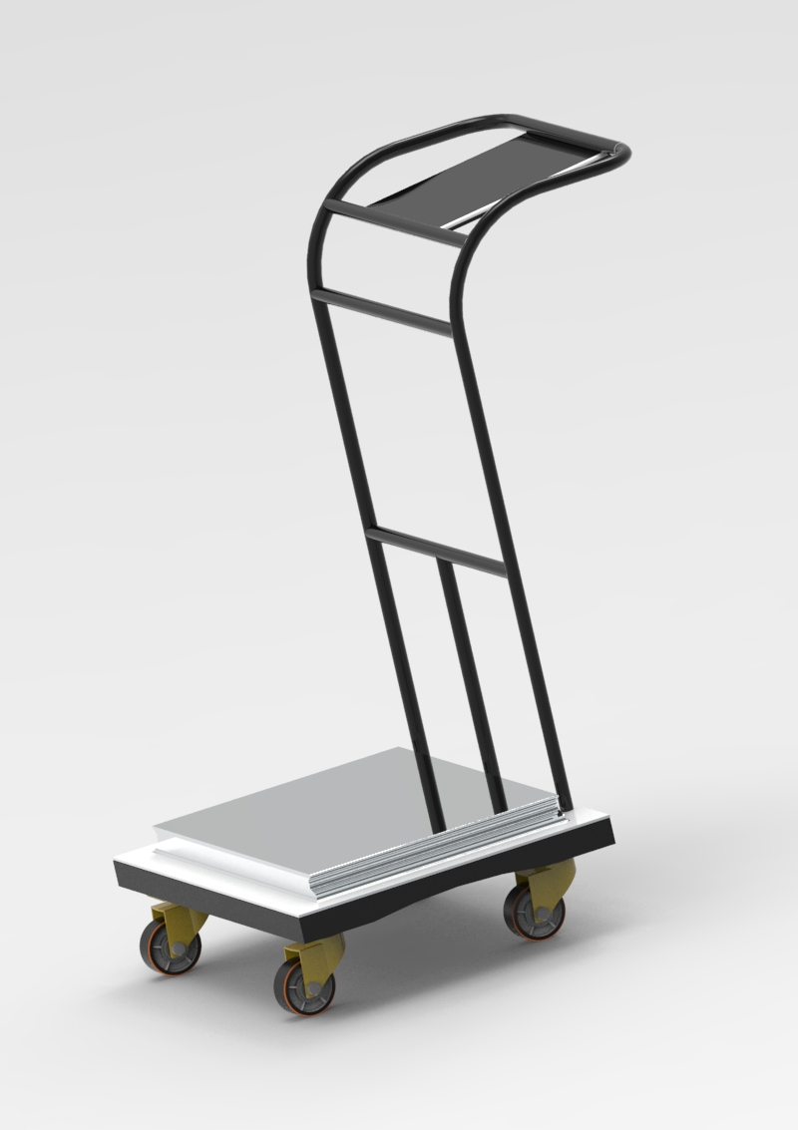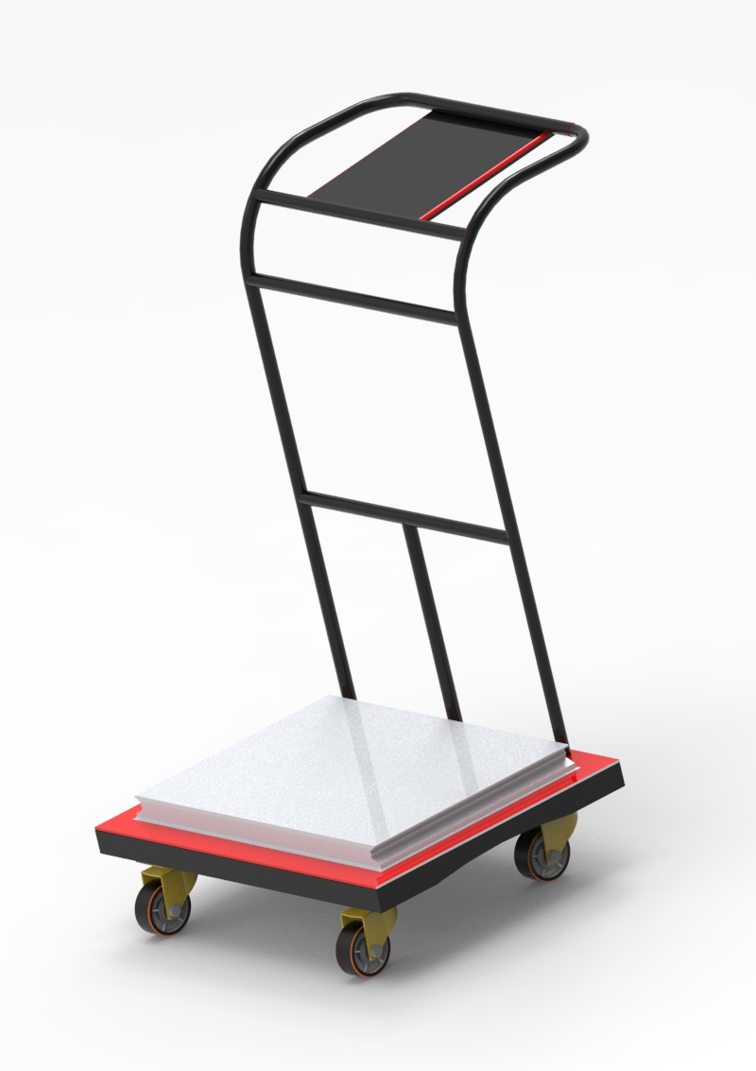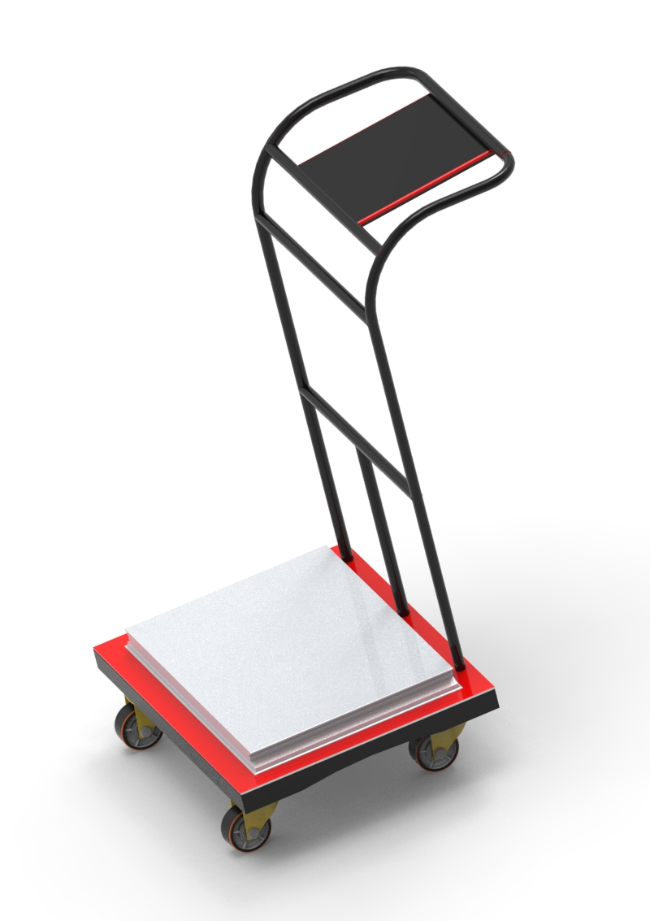

* Animated version of the product, showing how it works and it smart features
* Selling punchlines

The Wetula fair weigh technology scales, ensure fairness, offers instant e-payments, provides real-time actionable data, gives financial service identity and provides guarantees for a transparent and inclusive financial service access for smallholder farmers and their trading partners with increased incomes.

It is easy to see that, reducing complexity for our customer helps reduce complexity for our vendor, lowering the friction to sell and to deliver our products. This means a more capital efficient model - one which would hopefully scale much quicker and cost less to build products, sell, and support customers.

For our software makes it:

1. **Easier to sell**
   * Shorter sales cycles-do not have to test extensively in a customer's environment.
   * Lends itself to tele sales, can demo over phone and Web, do not need a huge sales infrastructure to close deals (just need quote bearing reps without a huge staff of sales engineers and professional services guys to get the job done).
   * Not a capital expense, usually sold as monthly or annual subscription which can many times be taken out of business budget as opposed to IT budget.
2. **Easier to install**
   * No messy installation process, long testing process, or fast hardware delivered to customer.
   * Can leave a customer and simply point them to a URL, train them over the phone, and get them up and running.
   * All of this means that the business can scale rapidly.
3. **Cheaper to support**
   * Browser-based delivery and richer client interfaces like DHTML make it easy to use for the customer - less training - less customer support costs.
4. **Easier to integrate**
   * Our standard APIs makes it easier for software delivered as a service to integrate disparate systems.
   * Once again, reduces costs to deliver product to customers and also removes obstacles to getting customers.
5. **Cheaper to build**
   * Versus a few years ago, bandwidth, storage, servers, and software are much cheaper now.
   * Think Linux, Intel boxes, cheap bandwidth, commodity software stacks, and smarter entrepreneurs changing the economics of building and delivering software as a service.
   * The economics speak for themselves.

* Smart Features

The current hardware (intelligent scale) measures weight by use of a load cell. Values collected by the hardware is then processed by a single board computer, encrypted and stored on a local database while passing these same collected values via an API to a cloud-based platform where the values are stored with respect to the unique user accounts.

The Wetula intelligent scale is a customized physical product built with custom hardware and integrated with custom software. This system is an online based platform, integrated with real-time data analytics, GPS location and time stamps for ease of product traceability and source trust. It is also integrated with digital payment capabilities and synchronously linked to the banking sector.

The PLA electronic casing heard, houses a single minicomputer (Raspberry pi 3 model B) and a microcontroller (Arduino Nano). The basic network architecture for the Wetula intelligent scale uses internet and GSM. The physical frame of the scale is modeled with 3D designs and schematically stimulated in visual rendering, that highlights for elimination and reduction in errors.

* Pricing Model

The uptake level for farmers is free whilst entry level for corporates is subscription based, subsidized by targeted advertisement utilizing Ad Sense by Google and paid corporate members. Whilst farmers subscription is field based, corporate entities will subscribe to bulk accounts and assign to their employees. However, all users are required to fill out registration to acquire their user names and passwords to access the site. The purpose of the free farmer access is to "tease" and encourage farmer subscription to eventually pay for the data and other value services.

Paying members will enjoy more benefits in using the services. The concept lately dubbed as software-on-demands, a chopped version of an open source application for various categories of members. However, corporate members will have to pay for the Applications Programming Interface (APIs) they need for their projects. The software will be cheaper and simpler in the deployment, as well as easy support.

* Product Description

Farmbridge Systems Limited offers both product packages and service packages that provide management solutions to smallholder farmers and other agriculture value chain actors at low cost. We also provide an online platform for the sector’s business actors to collaborate on both production and marketing type of projects. Farmers once logged in or in their back office, will be able to access their own data using dynamic forms that enable them to view or export their data. They can also build and generate simplified business plan pagers.

The body of the scale is made of food grade stainless steel and fitted with an S type load cell at the base with a PLA printed head casing for the electronic housing. The scale comes in handy and is fitted with four castor wheels at the bottom for ease of mobility. The PLA heading is fitted to round 4mm steel pipes at the top, with a platform tilted backwards for easy viewing and handling.

CUSTOMER SEGMENTS PAGE

* Animation Illustrating how the platform works from the perspective of the customer
* Benefits

The wetula intelligent scale collects and stores farmers’ information, farmland information, trade transaction information and scale readings unique to every individual. Also, the system is cable of retrieving and displaying farmers’ information, using custom RFID write strings or user account protocols to view values unique to individual or personal accounts only.

* Registration Requirements

Phone number, email address and National Identifications (eg; Drivers’ License, Voters ID, Traveling Passport or NIA Cards)